**INVENTION DISCLOSURE FORM**

**Applicant Name-BML Munjal University**

**Applicant Address-**

**Particulars of Inventors**

|  |  |  |  |  |  |  |
| --- | --- | --- | --- | --- | --- | --- |
| Mr./Ms/Dr. | Name (Full) | Department | Designation | Mobile No. | Email | Postal Address |
| 1. | Garlapati Sai Sri Charan | CSE | Student | 7989851445 | garlapatisai.sricharan.24cse@bmu.edu.in | 67th Milestone, National Highway – 8, Sidhrawali, Gurugram, Haryana - 122413 |
| 2. | Javvadi Sri Surya | CSE | Student | 7337027937 | javvadisri.surya.24cse@bmu.edu.in | 67th Milestone, National Highway – 8, Sidhrawali, Gurugram, Haryana - 122413 |
| 3. | Karthikeya Vabbalareddi | CSE | Student | 6301015078 | karthikeya.vabbalareddi.24cse@bmu.edu.in | 67th Milestone, National Highway – 8, Sidhrawali, Gurugram, Haryana - 122413 |
| 4. | Kotti Keerthana Rama Lakshmi | CSE | Student | 7207711289 | kottikeerthana.ramalakshmi.24cse@bmu.edu.in | 67th Milestone, National Highway |

**Provide a brief descriptive title of the invention:**

Alzheimer’s Location Tracking Device(SAFE ZONE)

**In 100 words or less, please provide an abstract or summary of the invention:**

This invention improves the safety and care of Alzheimer’s patients through a specialized watch. It offers real-time GPS tracking so caregivers can monitor the patient’s location continuously. The geo-fencing feature creates virtual boundaries, sending alerts if the patient moves outside safe zones to prevent wandering and getting lost. The watch also includes an SOS alert button for emergencies, notifying caregivers or family members immediately. Additionally, a secure locking mechanism prevents unauthorized removal, ensuring constant protection. This device reduces caregiver stress by enabling continuous monitoring and timely alerts, enhancing patient safety and independence.

**Detailed description of the invention:**

**a. Problem the invention is solving**

Alzheimer’s patients often face challenges such as memory loss, confusion, and disorientation, which can lead to wandering away from safe environments and getting lost. This not only puts patients at risk of harm but also causes immense stress and anxiety for caregivers and family members who struggle to monitor the patient constantly. Existing solutions are either too expensive, complex, or fail to provide real-time location tracking combined with emergency alerting and tamper prevention. There is a clear need for an affordable, reliable, and user-friendly device that ensures continuous safety monitoring and quick emergency response for Alzheimer’s patients.

**b. General Utility/application of the invention**

This invention is a wearable smartwatch designed specifically for Alzheimer’s patients. Its primary utility is to provide real-time location tracking via GPS, enabling caregivers to know the exact whereabouts of the patient at all times. It also supports geo-fencing, which creates virtual safe zones and alerts caregivers if the patient moves outside these boundaries. The device includes an SOS button for emergencies, enabling patients to send immediate alerts to caregivers or family members. A secure locking mechanism prevents unauthorized removal, ensuring the watch remains functional and attached at all times. This invention is useful in homes, care facilities, hospitals, and outdoor environments.

**c. Advantages of the invention disclosing about the increased efficiency/efficacy**

**1. Real-Time GPS Tracking:**

Provides continuous and precise location data, reducing the risk of lost patients.

**2. Geo-Fencing Alerts:**

Automatically notify caregivers when patients stray beyond safe zones, allowing timely intervention.

**3. Tamper-Proof Locking:**

Prevents patients from removing the device unintentionally or intentionally, maintaining continuous monitoring.

**4. Affordable and Easy to Use:**

Designed to be low-cost without sacrificing functionality, making it accessible to a wider population.

**5. Reduced Caregiver Stress:**

Continuous monitoring and alerts significantly reduce anxiety and workload on caregivers.

**6. Increased Patient Independence:**

Patients can move freely within safe zones without constant supervision, improving quality of life.

**d. Best way of using the invention as well as possible variants**

**Best Usage:**

* Patients should wear the smartwatch at all times, especially when outside their homes or care centers
* Caregivers use a connected web platform to monitor GPS location and receive alerts.
* Geo-fence boundaries should be set according to each patient’s safe environment (home, neighborhood, park).
* The locking mechanism should be adjusted to patient comfort while maintaining security.
* Caregivers should receive low-battery alerts to prevent sudden shutdown.

**Possible Variants:**

* GPS signals are often weak indoors; a barometer helps bridge this gap in multi-story homes, hospitals, or care centers.
* Integration with health monitoring sensors (heart rate, fall detection) for additional patient safety.
* Use of different communication protocols (e.g., GSM, LTE) for wider coverage.
* Customizable alert settings based on patient needs.
* Enhanced battery life or solar charging options for longer use.
* Addition of voice assistance or reminders for medication.

**e. Working of invention along with Drawing, schematics and flow diagrams if required with complete explanations**

### **Working of the Invention:**The current prototype of the smartwatch system uses an A7672S GPS module for real-time location tracking. The GPS module receives satellite signals to determine the patient’s coordinates (latitude and longitude), which are transmitted to a caregiver’s web interface through builtin GSM connection in the GPS module as Fig(2).

* **Power Supply**: As of now, the circuit is powered via a laptop connection through USB or GPIO pins, since a rechargeable battery hasn't been integrated yet.
* **Geo-Fencing:** Safe zones are predefined in the software. If the patient moves beyond these zones, an automatic alert is sent to caregivers.
* **SOS Alert & Emergency Contact:** When the SOS button is pressed, the system immediately sends the patient’s current location to predefined emergency contacts.
* **Circuit Design**: Due to the current size of components, the circuitry is housed in a custom enclosure box, not yet miniaturized to fit into a wearable watch form as in fig(1).
* **Locking Mechanism:** Not implemented in the current prototype; future versions will include a tamper-proof watch strap with locking.

Despite some features still in development, the system is functional for live tracking, geofencing, SOS alerts, and emergency contact integration, offering key safety benefits for Alzheimer’s patients.

**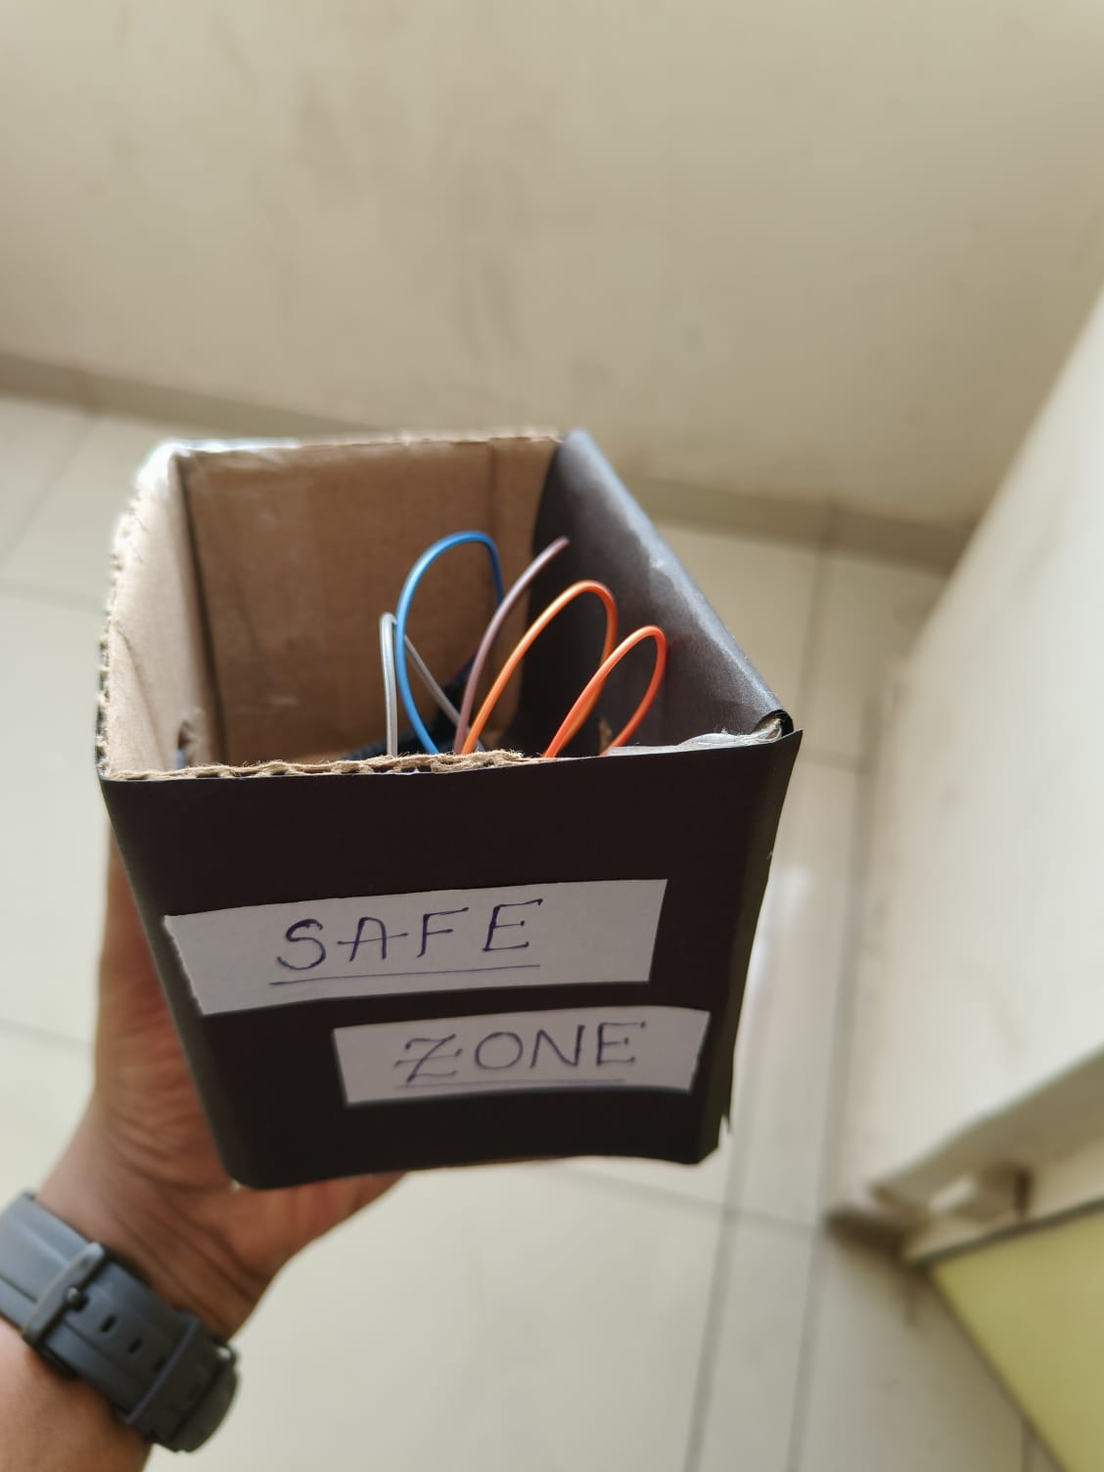 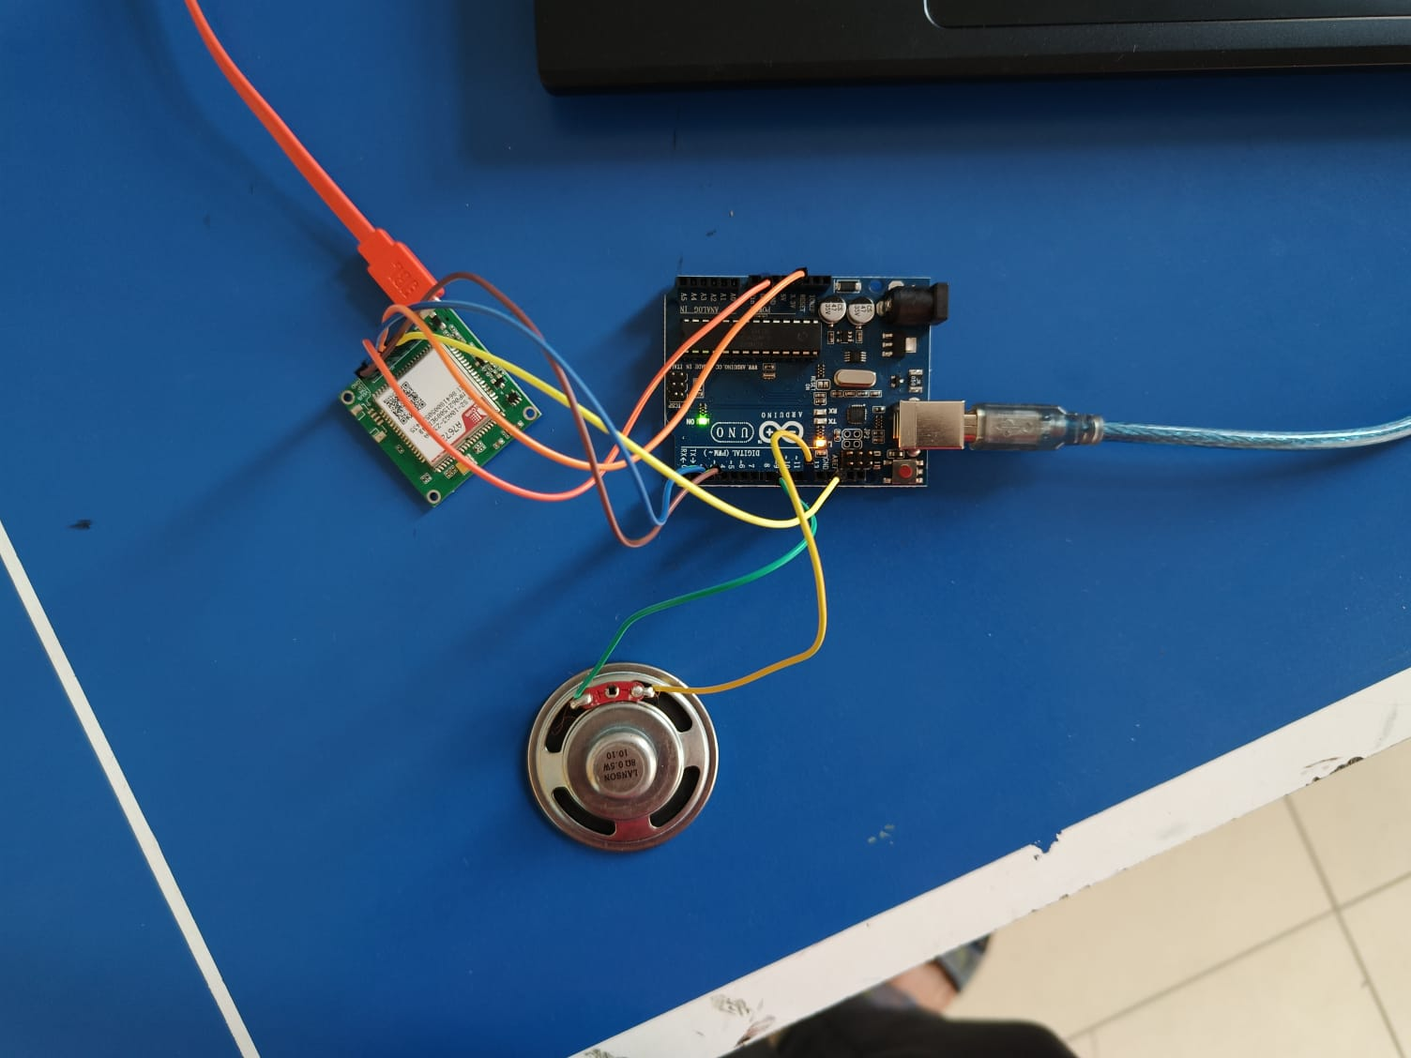   
 FIG(1) FIG(2)**

**Circuit Components:**

* **A7672S GPS Module:** For location tracking.
* **Microcontroller (Arduino UNO):** Controls GPS module, processes data, and manages communication.
* **Buzzer:** Provides audible alerts.
* **SOS Button:** Allows patients to trigger emergency alerts.
* **Locking Mechanism(TO BE ADDED) :** Prevents unauthorized removal.
* **Battery and Charging Circuit(TO BE ADDED):** Powers the watch.

**FLOW OF THE DEVICE:**

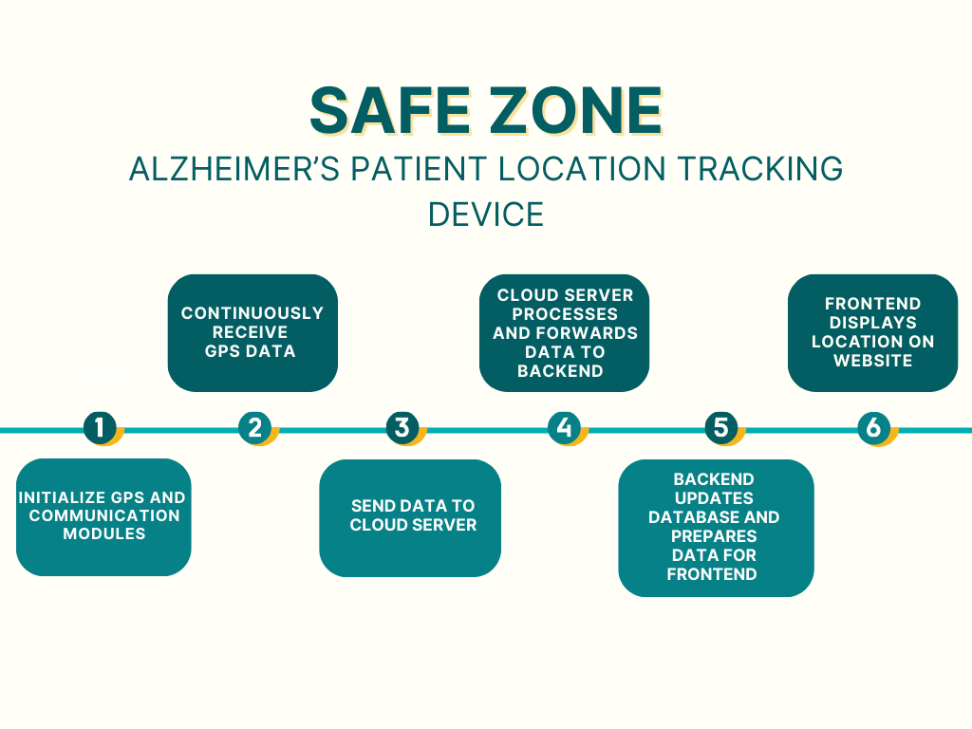

**STEP 1:** The tracking device powers on and sets up its GPS and communication systems.  
 This prepares the device to start receiving and transmitting location data.

**STEP** 2: The GPS module collects real-time location coordinates of the patient.  
 This data is updated constantly to ensure accurate tracking.

**STEP** 3: The device sends the collected GPS data to a cloud-based server.  
 This allows remote access and central processing of location data.

**STEP** 4: The cloud server validates and formats the incoming GPS data.  
 It then forwards this information to the backend system for storage and use.

**STEP** 5: The backend stores the location in a database and structures it for visualization.  
 It ensures the frontend can fetch up-to-date and readable data.

**STEP** 6: The patient’s current location is shown on a web interface.  
 Caregivers can monitor movement in real-time through the site.

**CIRCUIT DIAGRAM:**

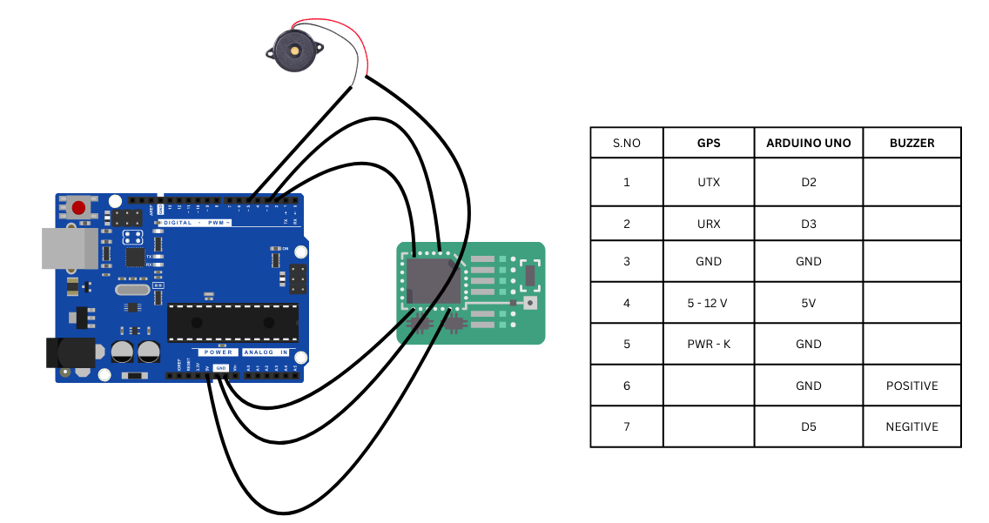

**OUR WEBSITE:**

1. **LANDING PAGE:**

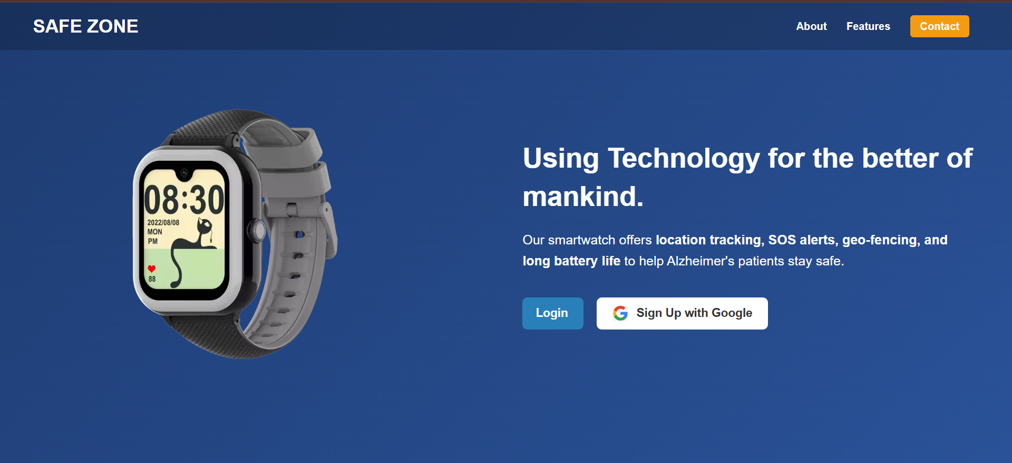

1. **LOGIN PAGE:**

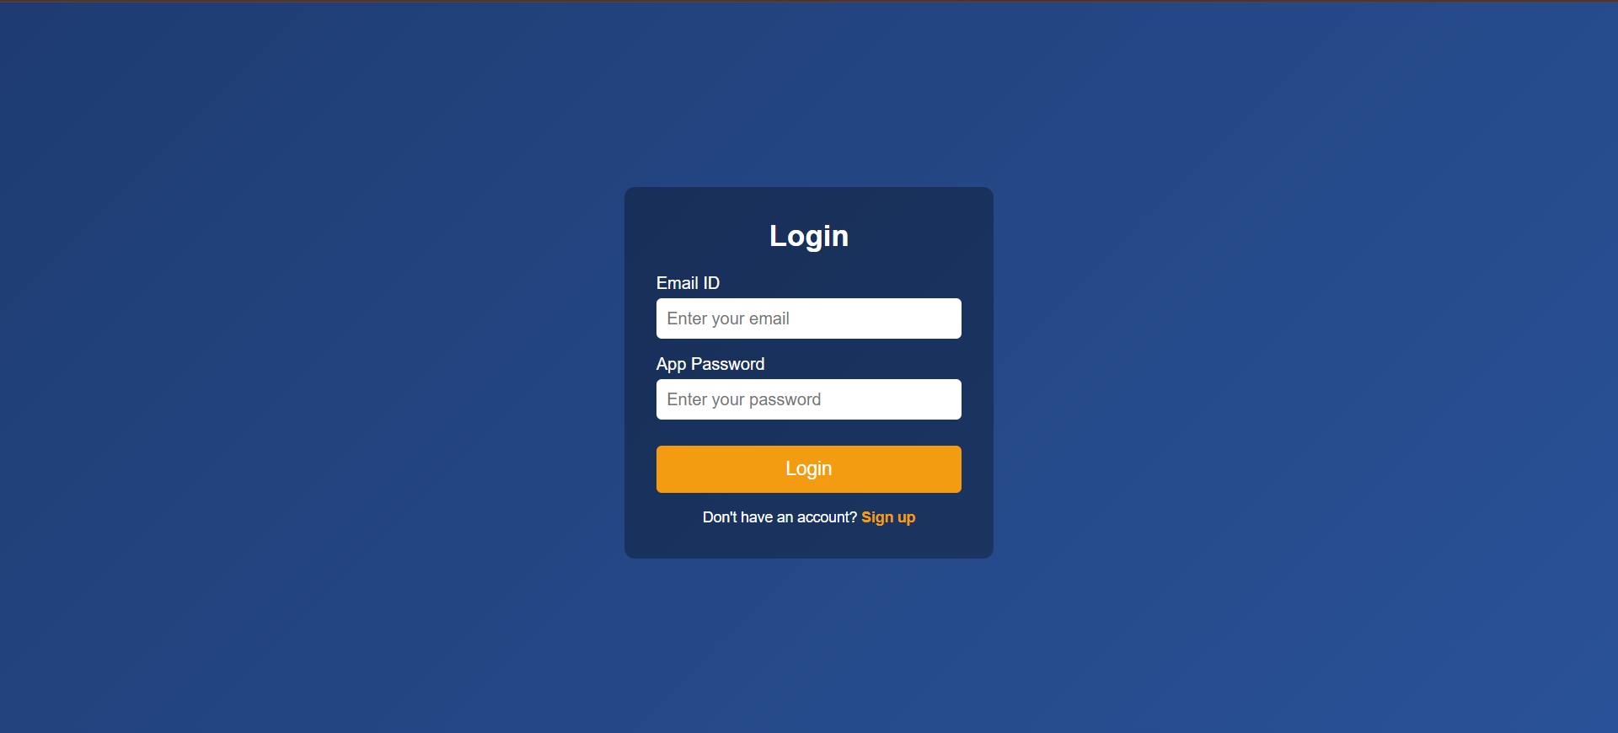

1. **NEW ACCOUNT SIGN UP PAGE:**

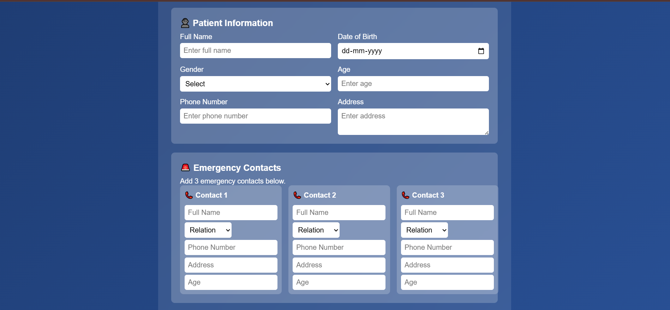

1. **PATIENT DASHBOARD:**

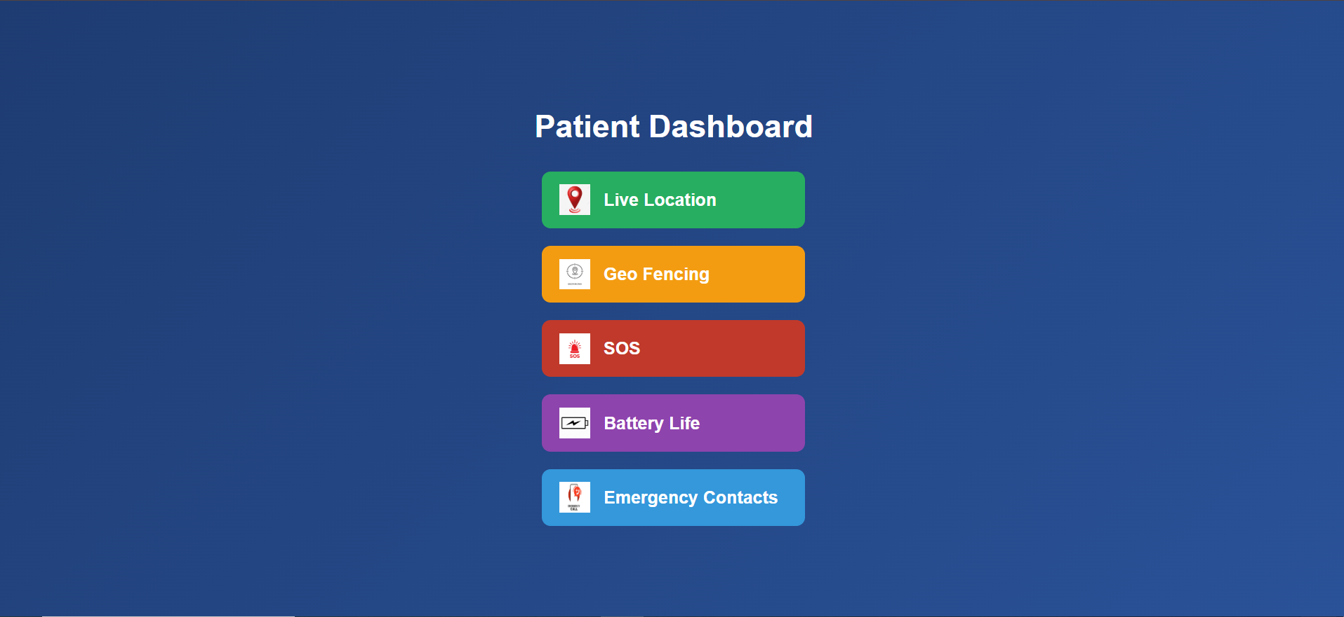

1. **LIVE LOCATION:**

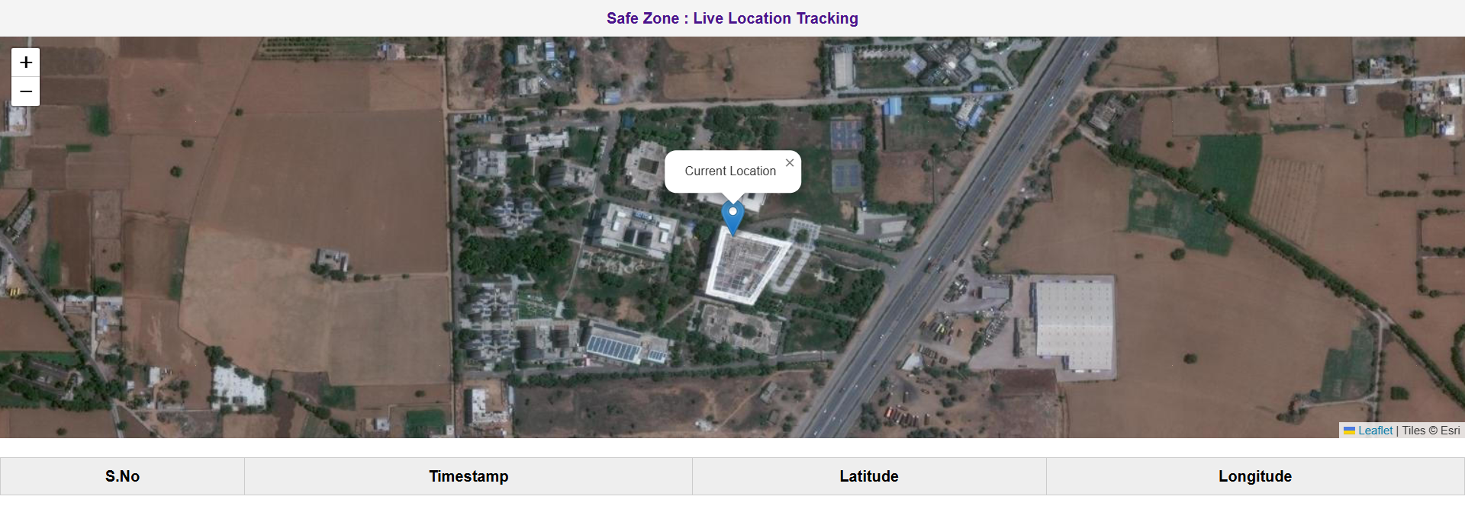

1. **GEO FENCING:**

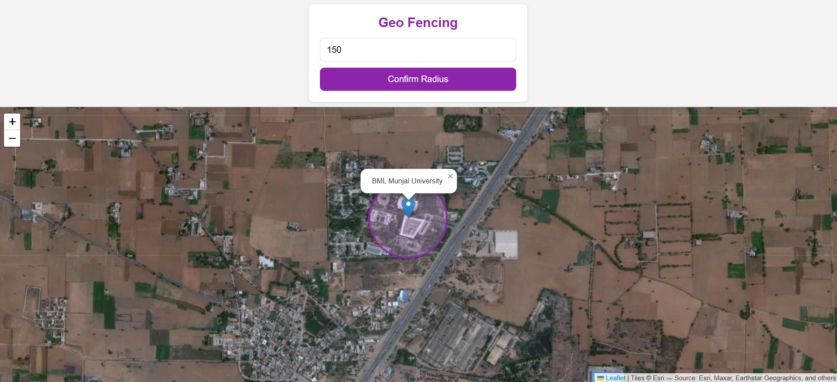

1. **SOS:**

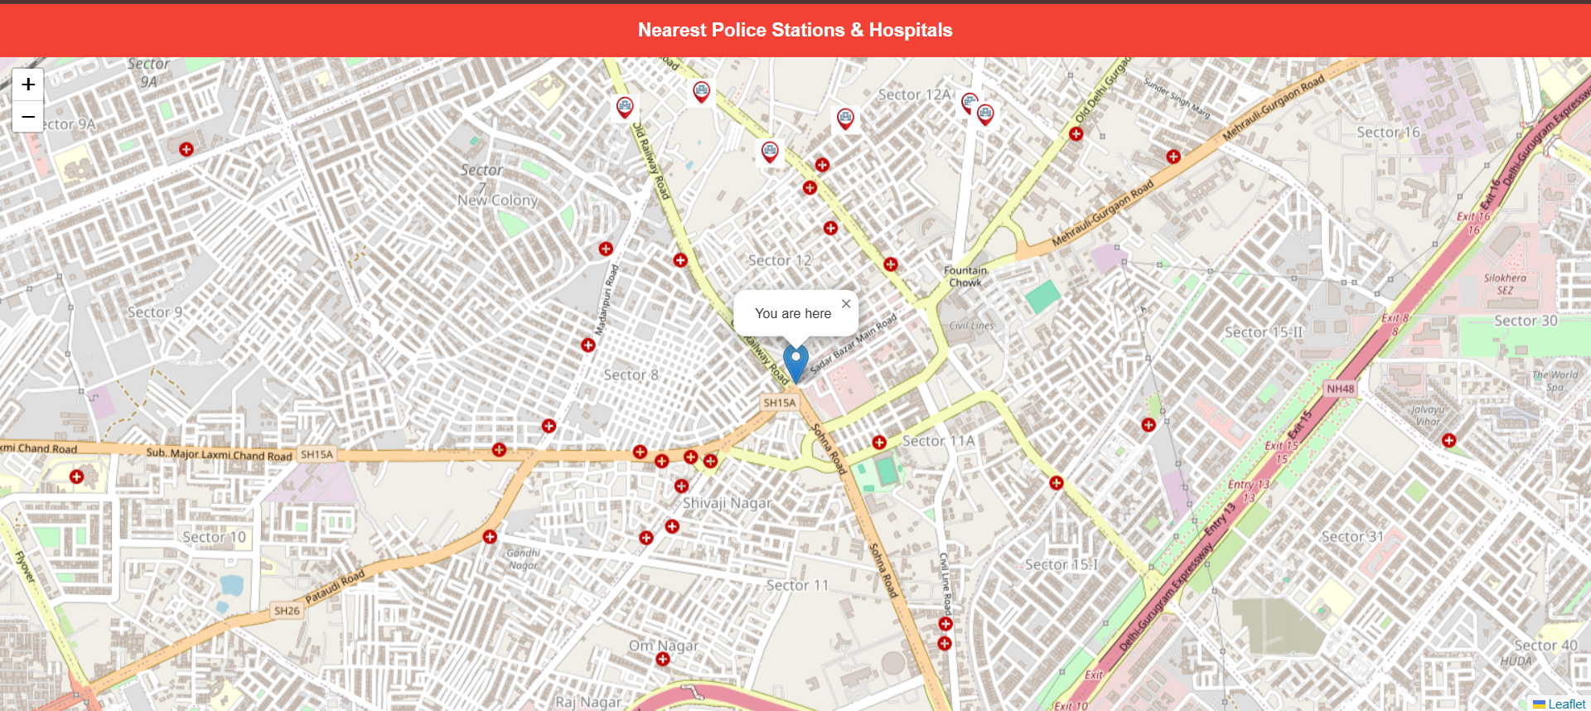

**Have you conducted a Primary Patent Search? Yes**

1. [Alzheimer's patient tracking system](https://patents.google.com/patent/US7825794B2/en)

|  |  |  |  |
| --- | --- | --- | --- |
| S. No. | Existing state of art | Drawbacks in existing state of art | Overcome (how your invention is overcoming the drawback) |
| 1. | |  | | --- | |  |  |  | | --- | | **US20160139273A1** – Wearable device with location tracking and geofencing | | Relies heavily on mobile apps and internet for alerts and tracking; not optimized for rural/low-connectivity regions.   |  |  |  | | --- | --- | --- | | Device cost and complexity may not be suitable for economically weaker sections.  Does not include a physical **locking mechanism** to prevent the patient from removing the device.   |  | | --- | | Alerts and geofencing limited to app notifications (requires smartphone use) |  |  | | --- | |  | |  |  | | --- | |  |  |  | | --- | |  | | Safe Zone uses **SMS and GSM-based alerts** that function even in areas without internet or smartphones   |  | | --- | | Designed with **low-cost components (Arduino, GSM module)** to ensure affordability and easy deployment |  |  |  |  | | --- | --- | --- | | Safe Zone adds a **tamper-resistant lock**, ensuring the device stays with the patient.   |  | | --- | | Geofencing alerts are **sent via SMS** directly to caregivers, **without smartphone dependency** |  |  | | --- | |  | |  |  | | --- | |  |  |  | | --- | |  | |
|  |  |  |  |

**List the Technical features and Elements of the invention along with the Description of your invention from start to end.**

### **Technical Features and Elements of the Invention (Safe Zone)**

1. **GPS Module (A7672S)**

Provides real-time latitude and longitude of the patient. Sends location updates via GSM when SOS is triggered or patient exits a geofenced area. Enables SMS and call functionalities to communicate with caregivers. Operates independently of internet service.

1. **Arduino Microcontrolle**r

Central processing unit that manages location tracking, geofencing logic, and communication. Programmed using the Arduino IDE.

1. **Tamper-Resistant Locking Mechanism**

Prevents unauthorized removal of the smartwatch. Can only be unlocked with a special tool or command, ensuring continuous monitoring.

1. **Geo-Fencing Feature**

Predefined safe zones stored in memory. If the patient exits this boundary, an alert is automatically triggered and sent via SMS.

1. **Emergency SOS Button**

Single-press button that immediately initiates a call and sends an SMS with the patient’s location. Allows the patient to request help proactively.

### 

### 

### 

### **Description of the Invention (Start to End)**

**Conception:** The idea emerged after observing that many Alzheimer's patients in India go missing due to memory loss and the lack of affordable real-time tracking tools. The solution had to be low-cost, independent of smartphones, and easy to use.

**Design & Components Selection:** A7672S was selected for combined GPS and GSM capabilities. An Arduino board was used for logic implementation due to its flexibility and accessibility for prototyping.

**Prototyping & Assembly:**  
 The hardware was assembled on a breadboard. Connections were established between Arduino, GPS module, buzzer, and SIM module. The entire circuit was housed in a secure box for field testing.

**Programming:** Arduino code was written to handle:

1. Initialization of GSM and GPS
2. Reading GPS coordinates
3. Triggering alerts based on location or button press
4. Sending messages and making calls to emergency contacts

**Testing**:  
 The device was tested within the BML Munjal University campus using live tracking, geofencing boundaries. The system worked as expected using SMS-based communication.  
**Demonstration**:  
 A demo was presented during the “JOE” course submission in May 2025. Real-time testing included triggering the SOS button and receiving GPS location via SMS.

### **Novel Features Compared to US7825794B2**

While US7825794B2 also proposes location monitoring for vulnerable individuals, Safe Zone distinguishes itself with:

* SMS-based alerts without need for centralized servers or smartphone apps
* Tamper-proof wearable lock to prevent patients from removing the device
* Emergency SOS feature directly integrated into the wearable
* Fallback mechanism for GPS failure
* Low-cost hardware setup, designed for scalability in rural or low-income environments.

**Has the invention been built or tested or implemented? If so, please provide the particulars of the first time it was successfully built or implemented (when, where, by whom, and evidence of this event including written or on-line pointers to documentary evidence):All testing details**

**Has the invention been built or tested or implemented?**

Yes, the invention has been partially built and tested as part of a prototype development stage.

#### **Particulars of the First Time it Was Successfully Implemented:**

* **When**: April–May 2025
* **Where:** BML Munjal University, Haryana, India
* **By Whom:** SRI CHARAN , KARTHIKEYA , SURYA , KEERTHANA
* **Project Title:** Safe Zone – A Wearable Safety and Tracking Device for Alzheimer’s Patients

**Implementation Details:**

* **Prototype Components Used:**

Arduino Uno, A7672 GPS Module , SIM card , Buzzer for local alerts, Breadboard-based circuit with locked casing

**Testing Performed:**

* **Live Location Tracking:** Successfully tested using A7672S, data transmitted via SMS with Google Maps link.
* **Geofencing Alerts:** Basic alerts were implemented to notify caregivers if the patient leaves the designated area.
* **Emergency SOS:** Button press triggered successful SMS and phone call to registered contact.
* **Power Supply via Laptop:** Module powered using USB from a laptop; portable battery circuit in progress

### **When and how was the idea first conceived?**

* We came up with the idea in SEPTEMBER 2024 while working on a project for our “DESIGN THINKING” course at BML Munjal University.
* We wanted to make something helpful for society. One of our team members shared a story about a family member with a disease similar to Alzheimer’s who got lost. That made us think about how we could help such people stay safe.
* We decided to build a wearable device that can send location and SOS messages without needing a smartphone or internet. We wanted it to be simple, low-cost, and easy to use, especially for families with fewer resources.

**Have you sold, offered for sale, publicly used or published anything related to this invention? If yes, please briefly explain the dates and circumstances. List those individuals to whom you have revealed your invention. Were non-disclosure documents signed prior to disclosure in each case? Please state any deadlines of which you may be aware of for filing an application on this invention.**

—NO—

**Include any reasons that your invention would not have been obvious to someone of average skill in the art.**

This invention is not something a regular developer or engineer would easily think of without **proper research and real-world understanding**. Here’s why:

1. **No Smartphone or Internet Needed:**  
    Most tracking devices today work with mobile apps or need the internet. We removed that need and made it work through simple SMS and call, which required research on GSM modules and fallback systems.
2. **Tamper-Proof Lock Design:** Making a wearable device that can’t be easily removed by the patient is not common. We studied how patients behave and added a lock system, which took time and testing to get right.
3. **Backup GPS Plan:**  
    If the GPS doesn’t work (due to signal issues), our device sends a last-known location instead of failing completely. This idea came from testing and learning how GPS behaves in different areas.
4. **Low-Cost, Rural-Friendly Design:**  
    We didn’t just use expensive tools. We researched low-cost components and made a design that families in villages can afford, which is not the main goal of most existing devices.
5. **All Features in One Device:**  
    Putting all of this — tracking, SMS, SOS, locking — in one small wearable took a lot of effort. It's not just technical work, but also understanding patient needs through interviews and research.

So, this invention needed both technical learning and deep research on real-life problems, which makes it non-obvious to someone with average skills who hasn’t studied or tested in this area.

### 

### **Additional Comments by Inventor:**

1. This device was designed with one main goal — to protect Alzheimer’s patients and bring peace of mind to their families. After seeing real-world cases where patients wandered off or were found too late, we knew something simple but effective was needed.
2. In the future, we plan to add a barometer sensor so the device can also track vertical movement, like going upstairs or falling down. This can help in detecting dangerous falls more accurately.
3. We also plan to build a health prediction system. The idea is to collect regular health and movement data and use it to predict if the person might faint or lose consciousness, based on patterns from the past. This can alert family members or caregivers in advance.
4. We strongly believe this device can save lives, especially in areas where people do not have access to smartphones or the internet. Our focus is on keeping it affordable, tamper-proof, and easy to use, even in rural locations.

This invention is not just a project — it’s a step toward **safer living for vulnerable people**, and we are committed to improving it further through feedback and research.